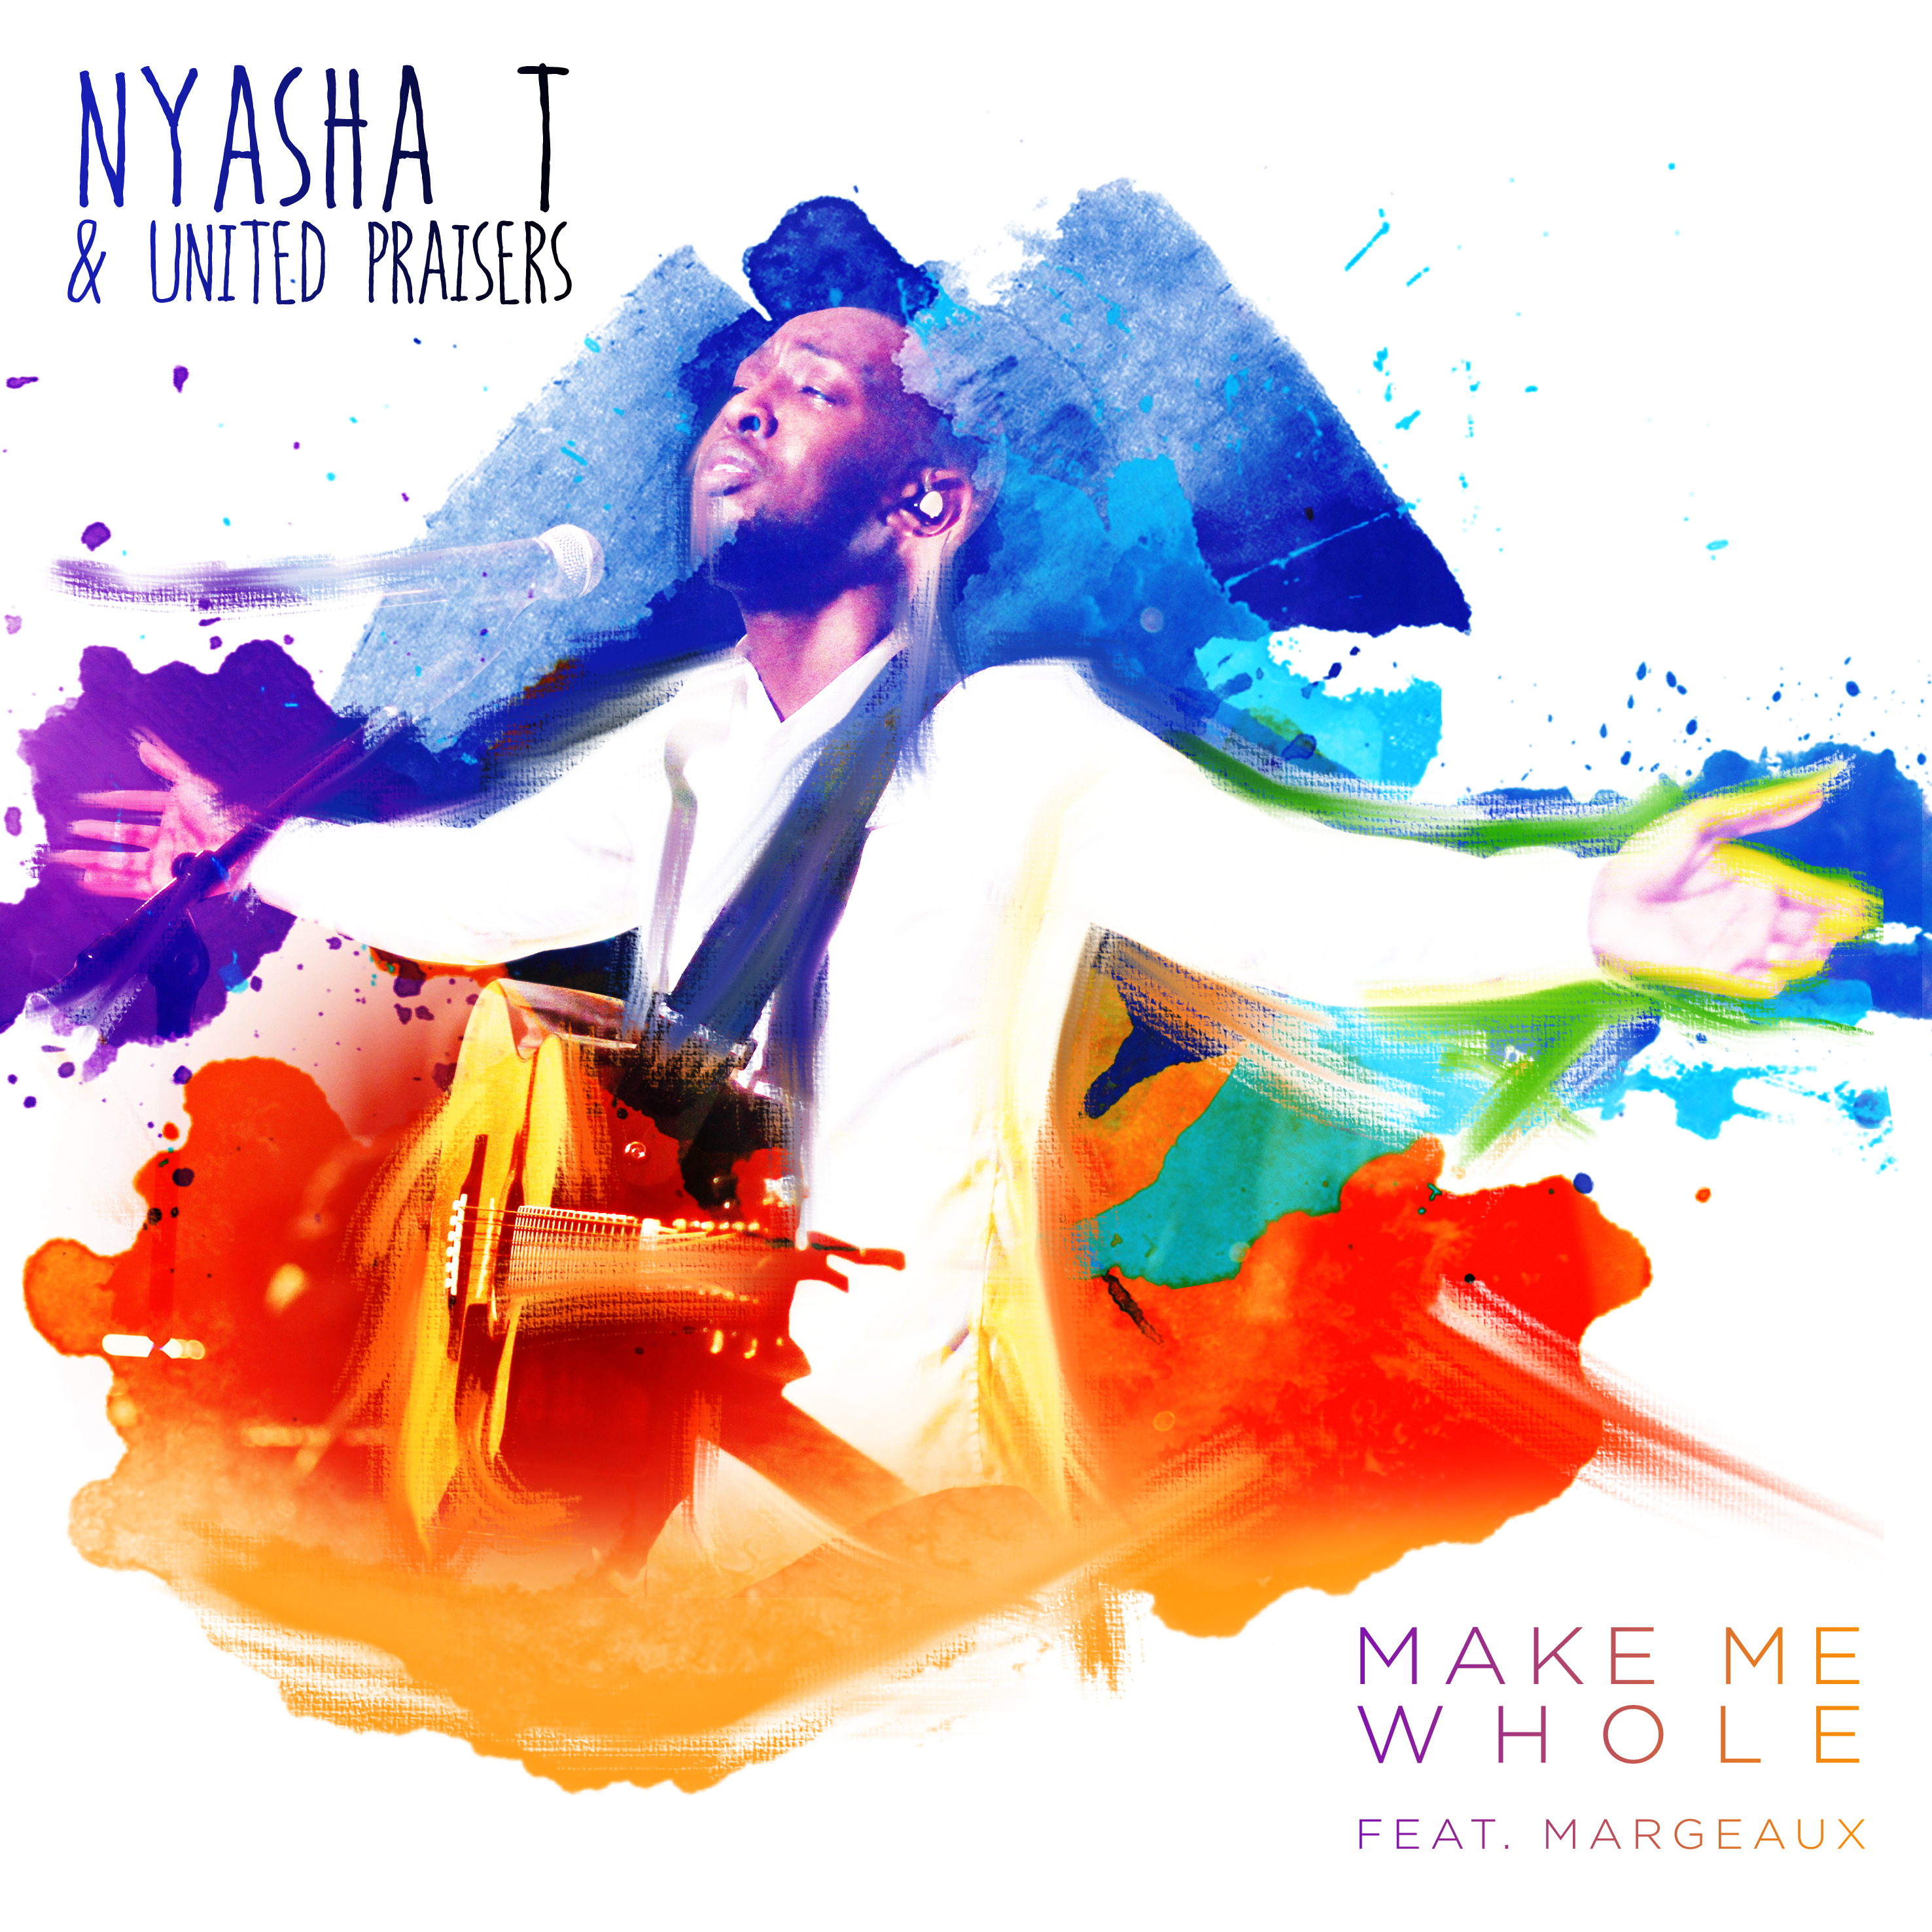
Following the successful release of his EP “Just the Beginning”, Singer, Songwriter and Worship Leader NyashaT announces the release of his new single "Make Me Whole" which will be available on iTunes, Google Play and Amazon, 30th of May. This is the first track to be lifted from the forthcoming Album " Arise and Shine".

Make Me Whole is a song of confession and redemption from a life of sin. The song is a cry to God for forgiveness and a cry to bring us closer to the Father. With its unique sound and beautiful harmonies, by up and coming gospel group United Praisers, all mixed into a powerful worship song, this song will surely ministers to every heart and soul.

NyashaT was exposed to singing from a young age, being part of his school choir and the worship team at Forward in Faith (Zaoga). However, he only started to take this seriously at the age of 15 when he joined New Wine Church (Woolwich, London) Youth Choir. While being part of the Youth choir, NyashaT was given the opportunity to lead worship. He later was moved to the New Wine Mass Choir where he is now one of the choir leaders working a long side Lawrence Johnson, who is known for his work with London Community Gospel Choir.

New Wine Mass Choir has opened doors for Nyasha to be able to work with the likes of Israel Houghton, Martha Munizzi, Micah Stampley, Nathaniel Bassey and several other high profile gospel artists. NyashaT is also a member of Riversongz, who are known for their work with Muyiwa and Riversongz.

NyashaT was born in Zimbabwe where he lived for 13 years of his life, before his family moved to Indiana, USA to find a better life. NyashaT later moved to the United Kingdom where he has spent all of his adult life. NyashaT’s life has been through ups and downs, but through trial and tribulation, the joy of the Lord was his strength. He is a testament of God’s grace, mercy and protection.

Having been exposed to different environments and styles of music has allowed NyashaT to not a single genre artist. Nyasha believes that he’s music appeal to a wide variety of people and that he’s music represents the new journey God is taking him on. His music is more than just songs, but are heart felt words to the Father and he is ready to tell the world.

Nyasha hopes that his new song Make Me Whole, ministers to the hearts of all people during their life’s journey. Knowing that we have all fallen short of God’s glory, but through Christ death on the cross for us we can still be saved.

The song is mixed by 7 Grammy award winning mixing engineer John (Yosh) Jaszcz known for his work with Gospel greats Israel Houghton, Smokie Norful, Marvin Sapp, Tye Tribbett and many more and produced by Chuks Chiejine of Playdough Music and Kuda Thondhlana of KNAT Productions.

Below is a link to a preview of the new single:
https://www.youtube.com/watch?v=ggSteNUkbUI

You can download the single today from the below links:
iTunes - https://itunes.apple.com/gb/album/make-me-whole-feat.-margeaux/id1116691182
Amazon - http://amzn.to/1TLr56K
Google Play - http://bit.ly/1XZjWlc

Nyasha T is available for bookings and interviews. Please contact Nyasha T Directly to set up a time that is convenient.
Tel: 0781 668 4501
Email: info@nyashatmusic.com

For more information, please visit:
Twitter - www.twitter.com/nyashat_music
Facebook - www.facebook.com/nyashatmusic
Instagram - www.instagram.com/nyashatmusic
YouTube - https://www.youtube.com/channel/UCLWLTG2An2xg03DusZheD8A
Website - www.nyashatmusic.com
Press Kit - www.presskit.to/nyashatmusic

